# Class: AuthenticationAPI – Move business logic from API to service

At first, we used to have the implementation for all the endpoints in our API class. Later we realised this was not ideal and decided to refractor the class. We ended up moving the business logic in the API, to the service. Which improved mainly ‘Lack of Cohesion’ by quite a bit.

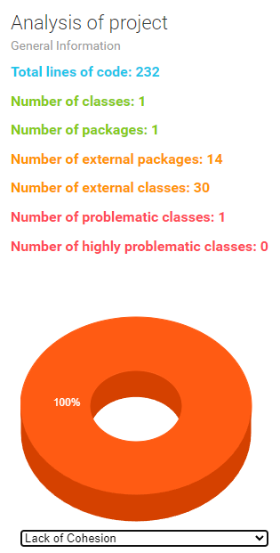

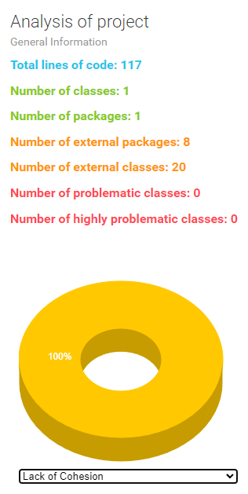

# Method: changePasswordUser (MyUserDetailService) - Make recurring code into separate method

The method ‘changePasswordUser’ had 2 recurring blocks of code, which was not efficient. This block has now been made into it’s own method (‘authenticateCredentials’) and this method is called twice. This prevents having duplicate code, improves readability and decreases lines.

